DISTRICT DISASTER MANGEMENT PLAN SIWAN
inception report
Contents
Disclaimer 3
1. Executive Summary and Introduction 4
2. Conceptual Framework of DDMP 5
a. Futuristic Plan with Historical Perspective 5
b. Understanding about DDMP (Multi-Hazard Focus) 6
c. Identifying current and potential risks 10
d. Action Oriented Plan 12
3. Scope of the Project 12
a. Approach for Comprehensive Plan 12
b. Consideration for lower administrative units below district – Block & Panchayat level interventions 12
c. Mainstreaming DRR & CCA to be taken into consideration 13
d. Value addition by agencies 13
4. Districts’ Profile 13
a. Multi-hazard focus - including vulnerabilities in terms of socio-economic details and also the capacities existing in the districts 13
b. DisasterRisk and Vulnerability Profile 14
5. Approach, Methodology and Activities 16
a. Data Sources – Primary & Secondary (including relevant maps) 16
b. Stakeholders’ involvement (including IDRN) 17
6. DDMP Preparation Planning & and Reporting Mechanism 18
a. Ensuring involvement and ownership of DDMAs 18
7. Timeline and Delivery Schedule (Table) 18
8. Monitoring and Evaluation System 20
9. Project Team 21
a. Team Leaders and other Team Members – CV (Qualifications and Experience), Roles and Responsibilities etc. 21

Disclaimer

The contents of this report are prepared by Caritas India for the exclusive purpose of presenting to Bihar State Disaster Management Authority (BSDMA)/ Districts under the provisions of the contract signed between the two. The contents of this report should not be published or used by anyone without prior written permission of BSDMA or Caritas India. All content is based on the information collected by Caritas India through primary and secondary sources including BSDMA and respective district website. While Caritas India has taken due care in collecting data only from verified sources, Caritas India is not liable for any misrepresented fact or error in such data.
We have made specific efforts to verify the accuracy and authenticity of the information gathered where it was felt necessary.

Executive Summary and Introduction
It is proposed to accelerate the District Disaster Management Plans in Bihar more Inclusive so as to make Bihar safer. Here, inclusive word is considered as “to collect voices of the vulnerable groups, i.e. poorest of poor, women, children, physically challenged, old aged, Dalits and minorities. Their needs should be fulfilled during emergencies. So, it is vital that the needs of the vulnerable groups should be included in the DDMPs. The focus of the work is on making District Disaster Management Plans directly focused on the risks faced by the poor and excluded communities, and at the same time make poor and excluded vulnerable communities have more direct say in District Disaster Management Plans. The proposal builds on ISDR call for more local action within HFA and UNDP push for building local DRR capacity with CSO-GO joint action, where Flagship schemes for advocacy are also incorporated.
The District Disaster Management Plans (DDMPs) are not looked at by Civil Society in a systematic way on its own or with the authorities. More focus on poor in DDMPs is missing, the DDMPs are more government exercise and in most cases civil societies are left out. The National Disaster Management Authorities has not reviewed DDMPs that are made by the districts with help from National Institute of Disaster Management guidelines and UNDP support.
As per Disaster Management Act 2005, there shall be a plan for disaster management for every district of the State. The District Plan shall be prepared by the District Authority, after consultation with the local authorities and having regard to the National Plan and the State Plan, to be approved by the State Authority. The District Plan shall include-

  - the areas in the district vulnerable to different forms of disasters;
  - the measures to be taken, for prevention and mitigation of disaster, by the Departments of the Government at the district level and local authorities in the district;
  - the capacity-building and preparedness measures required to be taken by the Departments of the Government at the district level and the local authorities in the district to respond to any threatening disaster situation or disaster;
  - the response plans and procedures, in the event of a disaster
On the basis of secondary data available the risk assessment of the districts has been done. These past data shows that there are chances of multi hazard threats in Buxar.
The approach towards the entire exercise would include secondary data collection, stakeholder mapping, survey tool development including development of questionnaire, checklist and draft template, training of local survey teams, primary data collection and use of GIS for hazard mapping, resource mapping and vulnerability mapping. District level consultation will be organised in each proposed project district during the project to revise the outline to make the DDMP Inclusive. This will be mainly with District, Disaster Management Authority (DDMA) and other line departments, PRIs, municipalities/ municipal corporations, grassroots organisations/CBOs and communities. This will be facilitated by Caritas India along with DDMA of the respective districts. The outputs will be the district level Advisory Committee of each district and detail timeline from district authorities to adopt the process and methodologies of Multi hazard DDMP.

Conceptual Framework of DDMP

Futuristic Plan with Historical Perspective
It is proposed to accelerate the District Disaster Management Plans in Bihar more Inclusive so as to make Bihar safer. Here, inclusive word is considered as “to collect voices of the vulnerable groups, i.e. poorest of poor, women, children, physically challenged, old aged, Dalits and minorities. Their needs should be fulfilled during emergencies. So, it is vital that the needs of the vulnerable groups should be included in the DDMPs. The focus of the work is on making District Disaster Management Plans directly focused on the risks faced by the poor and excluded communities, and at the same time make poor and excluded vulnerable communities have more direct say in District Disaster Management Plans. The proposal builds on ISDR call for more local action within HFA and UNDP push for building local DRR capacity with CSO-GO joint action, where Flagship schemes for advocacy are also incorporated.

The District Disaster Management Plans (DDMPs) are not looked at by Civil Society in a systematic way on its own or with the authorities. More focus on poor in DDMPs is missing, the DDMPs are more government exercise and in most cases civil societies are left out. The National Disaster Management Authorities has not reviewed DDMPs that are made by the districts with help from National Institute of Disaster Management guidelines and UNDP support.

Disaster Management is still with government sector (largely) and government functionaries at the cutting edge level are not at all involved in building Community Managed Disaster Risk Reduction (CMDRR) ex-ante (and also do not have enough skills to do that). Hence, dependence of CMDRR is very high on the NGO and civil society. Ex-ante resource availability with NGOs, especially in the less frequency and high intensity zone is not adequate to keep pre disaster interest alive. The experience after all the past disasters and calamities is that the most vulnerable and marginalized Dalit communities and their women, children and aged were the people who were again the most affected and yet the discriminated in every aspect of the relief works: in identifying them as victims in the disaster, in evaluating their losses, and including them in the planning, monitoring and implementation of programmes for their future rehabilitation. Vulnerable groups have thier rights during various stages of disasters. And thus, right based approach during response and mitigation is important and therefore, right based disaster management planning is key and vital to make it inclusive in its real manner.

Understanding about DDMP (Multi-Hazard Focus)
As per Disaster Management Act 2005, there shall be a plan for disaster management for every district of the State. The District Plan shall be prepared by the District Authority, after consultation with the local authorities and having regard to the National Plan and the State Plan, to be approved by the State Authority. The District Plan shall include-

    - the areas in the district vulnerable to different forms of disasters;
    - the measures to be taken, for prevention and mitigation of disaster, by the Departments of the Government at the district level and local authorities in the district;
    - the capacity-building and preparedness measures required to be taken by the Departments of the Government at the district level and the local authorities in the district to respond to any threatening disaster situation or disaster;
    - the response plans and procedures, in the event of a disaster, providing for-
      - allocation of responsibilities to the Departments of the Government
At the district level and the local authorities in the district;
      - prompt response to disaster and relief thereof;
      - procurement of essential resources;
      - establishment of communication links; and
      - the dissemination of information to the public;
      - Such other matters as may be required by the State Authority.
Bihar is affected by various disasters viz. floods, earthquakes, cyclone, heat wave and cold wave.
Table showing Decadal Multi-Disasternumberof deaths (www.ncrb.nic.in)
Year | ColdWave | Cyclone | Earthquake | Flood | HeatWave | Landslide
2001 | 27 | 14 | 0 | 36 | 47 | 6
2002 | 55 | 4 | 2 | 126 | 22 | 1
2003 | 176 | 8 | 1 | 63 | 70 | 11
2004 | 72 | 9 | 0 | 204 | 32 | 10
2005 | 27 | 11 | 1 | 26 | 68 | 8
2006 | 81 | 4 | 3 | 16 | 52 | 2
2007 | 97 | 14 | 5 | 477 | 58 | 18
2008 | 103 | 4 | 0 | 408 | 28 | 0
2009 | 98 | 0 | 1 | 99 | 46 | 7
2010 | 156 | 26 | 0 | 94 | 95 | 9
2011 | 174 | 22 | 6 | 186 | 86 | 15

History ofFlood in Bihar
Bihar is India’s most flood-prone State, with 76 percent of the population, in the north Bihar living under the recurring threat of flood devastation. About 68800 sq Km. out of total geographical area of 94160 sq Km. comprising 73.06 percent is flood affected.
The plains of Bihar, adjoining Nepal, are drained by a number of rivers that have their catchmentsinthesteep and geologicallynascentHimalayas.Kosi,Gandak, BurhiGandak, Bagmati,KamlaBalan,MahanandaandAdhwaraGroupofriversoriginatesinNepal,carry high dischargeandvery highsedimentloadanddropsitdownintheplainsofBihar.About65%of catchmentsareaoftheseriversfallsinNepal/Tibetandonly35%ofcatchmentsarealiesin Bihar.Intheyears1978,1987,1998,2004and2007Bihar witnessedhighmagnitudesofflood. Thetotalareaaffectedby floodshasalsoincreasedduring theseyears.Floodof2004demonstratestheseverityoffloodproblemwhenavastareaof23490Sq Km. was badlyaffected bythefloods ofBagmati, Kamla&Adhwaragroups of riverscausing lossof about 800 human lives, even whenGanga,the masterdrain was flowinglow.
Table:FloodDamageduring 2001 to 2011
Yea  r | Area  affec ted  in  (m. ha.) | Popul  ationaffect ed in (milli on) | Damageto  crops |  | Damageto  houses |  | Cattle  lost  Nos. | Human  life lost  Nos. | Damag  eto Public Utilities in Rs. crore | Total  damages  Crops, houses & public utilities in Rs. crore
 |  |  | Area  (m. ha.) | Value  (Rs. crore) | Nos. | Value in  Rs. crore
2001 | 1.195 | 9.091 | 0.650 | 267.218 | 222008 | 173.584 | 565 | 231 | 183.538 | 624.340
2002 | 1.969 | 16.018 | 0.941 | 511.495 | 41914 | 526.215 | 1450 | 489 | 408.922 | 1446.632
2003 | 1.508 | 8.798 | 0.610 | 62.660 | 45262 | 20.320 | 106 | 251 | 1035.160 | 1118.140
2004 | 2.700 | 29.985 | 1.399 | 522.056 | 929773 | 758.095 | 3272 | 885 | 1030.496 | 2310.647
2005 | 0.460 | 2.639 | 0.135 | 11.640 | 5538 | 3.828 | 4 | 58 | 3050 | 18.518
2006 | 0.182 | 1.089 | 0.086 | 7.060 | 18637 | 12.260 | 31 | 36 | 84.562 | 103.882
2007 | 1.880 | 2.780 | 1.060 | 768.378 | 784328 | 831.445 | 2423 | 1287 | 642.415 | 2242.239
2008 | 0.882 | 6.212 | 0.367 | 34.196 | 297916 | 84.514 | 878 | 252 | 97.710 | 216.420
2009 | 1.105 | 2.338 | 0.040 | 21.830 | 7674 | 5.282 | 2 | 97 | 5.301 | 32.413
2010 | 0.199 | 1.075 | 0.010 | 3.119 | 15170 | 7.049 | 0 | 100 | 1.592 | 11.760
2011 | 0.000 | 0.581 | 0.163 | 59.870 | 34906 | 17792 | 39 | 143 | 25.786 | 103.448

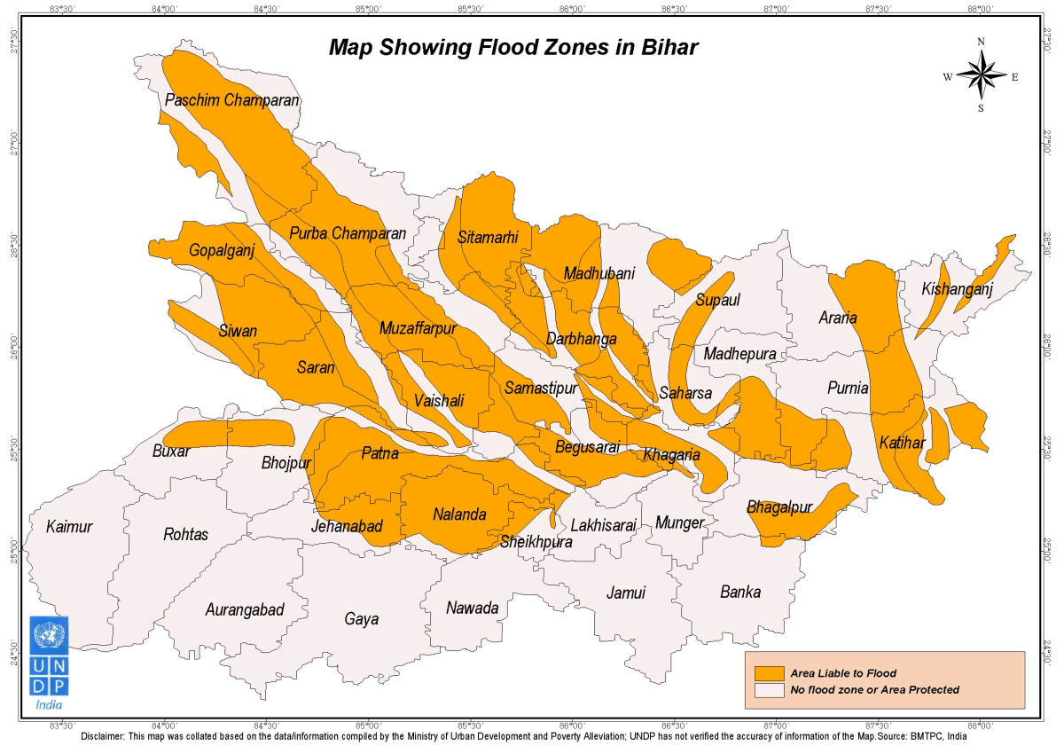

Earthquake:-
AccordingtoGlobalSeismic HazardAssessmentProgram(GSHAP) data,the stateofBihar lies ina regionwithmoderate tolowtohighseismic hazard. As per the 2002BureauofIndian Standards(BIS)map,thisstatealsofallsinZonesIII,IV& V.Historically,thisregionhas experienced earthquakein theM5.0-7.0 range.

EarthquakeHistory of Bihar
The stateofBiharliesintheGangeticPlain.Thisisa fore-deep,a downwarpoftheHimalayan foreland,ofvariabledepth,convertedintoflatplainsby long-vigoroussedimentation.Thisis knownasageosynclineandtheGangeticPlainistheIndo-GangeticGeosyncline.Thishas shownconsiderableamountsofflexure anddislocationatthenorthernendandisboundedonthe northby theHimalayanFrontalThrust.TheflooroftheGangetictrough(ifseewithoutallthe sediments) isnotaneven plain (5),butshowscorrugatedinequalities and buriedridges (shelf faults). WesternBihar sitsonthe sub-surface Faizabadridge while the eastern sectionssitonthe Munger-Saharsa Ridge.theareas neartheborderwithWestBengallieontheKosiGraben (Purnea-KasganjGraben). The centralsectionsofBihar lie (5) atopthe Gandakdepressionand EastUttar Pradeshshelf.The Himalayan FrontalThrustdoesnotrun inBihar,though,itruns acrossthe border inNepal. Several faultshave beenidentifiedinthe regionandsome(1) have shownevidence of movementduringthe Holocene epoch.The WestPatna FaultrunsinaNE- SWdirectionfromnearArrahinthesouthtotheNepalese bordernear Madhubaniinthenorth. RunningalmostparalleltoitistheEastPatnaFaultwhichextendsfromthesouth-eastofPatnainthe southtothe Nepalese border tothe eastofMadhubani.Anotherfault,thisone alsolying paralleltothe previoustwo,isthe Munger-Saharsa RidgeFaultwhichrunsfromBiharsharif to nearMorang ineasternNepal.Apartfromthesethereareeast-westrunning tearfaultsinthe regionthatcontrol(5)thecoursesofthemainrivers.However,itmustbestatedthatproximity tofaultsdoesnotnecessarily translateintoahigherhazardascomparedtoareaslocatedfurther away,asdamagefromearthquakesdependsonnumerousfactorssuchassubsurfacegeology as wellas adherenceto thebuildingcodes.The 1934Bihar earthquake wasone of theworstearthquakesinIndia'shistory. Some 30,000 peopleweresaidtohavedied.MungerandMuzaffarpurwerecompletely destroyed.This8.1 magnitudeearthquakeoccurred on January15, 1934 at around 2:13 PM (I.S.T.)(08:43 UTC) and causedwidespreaddamage inthenorthern BiharandinNepal.The epicentre for thiseventwas located in the eastern Nepal about 240 km awayfrom Kathmandu.

Seismic Hazard
TheseismichazardmapofIndiawasupdatedin2000(4)by theBureauofIndianStandards (BIS). Thereare nomajor changesinthe zonesinBihar.DistrictssuchasAraria,Darbhanga, Madhubani,SitamarhiandSupaullieinZoneV.The south-westerndistrictsofAurangabad, Bhojpur,Buxar, Gaya,Jahanabad,Kaimur, NawadaandRohtaslie inZoneIII.The remaining districts of Bihar, includingthecapital cityof Patnaliein ZoneIV.

EarthquakeZones mapofBihar
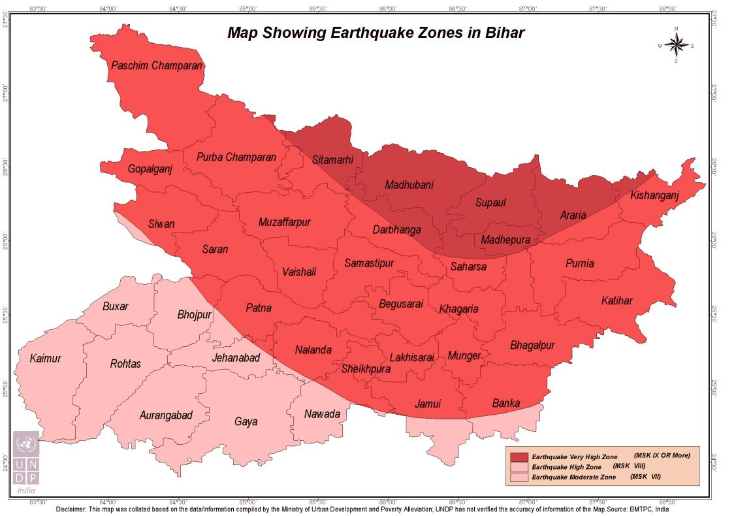

Identifying current and potential risks
On the basis of secondary data available the risk assessment of the districts has been done. These past data shows that there is are chances of multi hazard threats in the given 4 districts. The below table shows the basic profile of the 4 districts.
District | Sub Divisions | Block | Panchayat | Villages | Population | Male | Female
Siwan | 2 | 19 | 332 | 1533 | 3,318,176 | 1,672,121 | 1,646,055
Figures as per census 2011

Hazard Profile of the Districts
District | Wind & Cyclone Zone | Earthquake Zone | Flood
Siwan | High Damage Risk Zone (Vb = 47m/s) | IV  (High Damage Risk Zone) | FLZ  Flood Zone / Area liable to Flood

The below mention maps are from the district administration website.
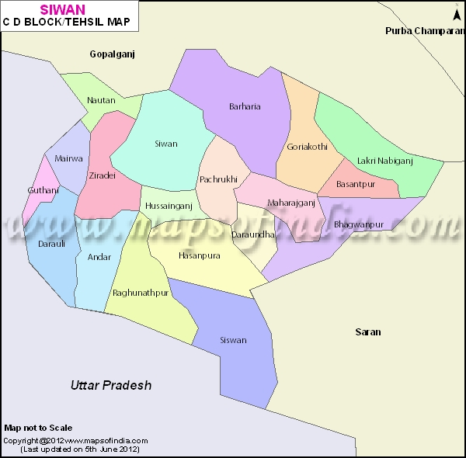
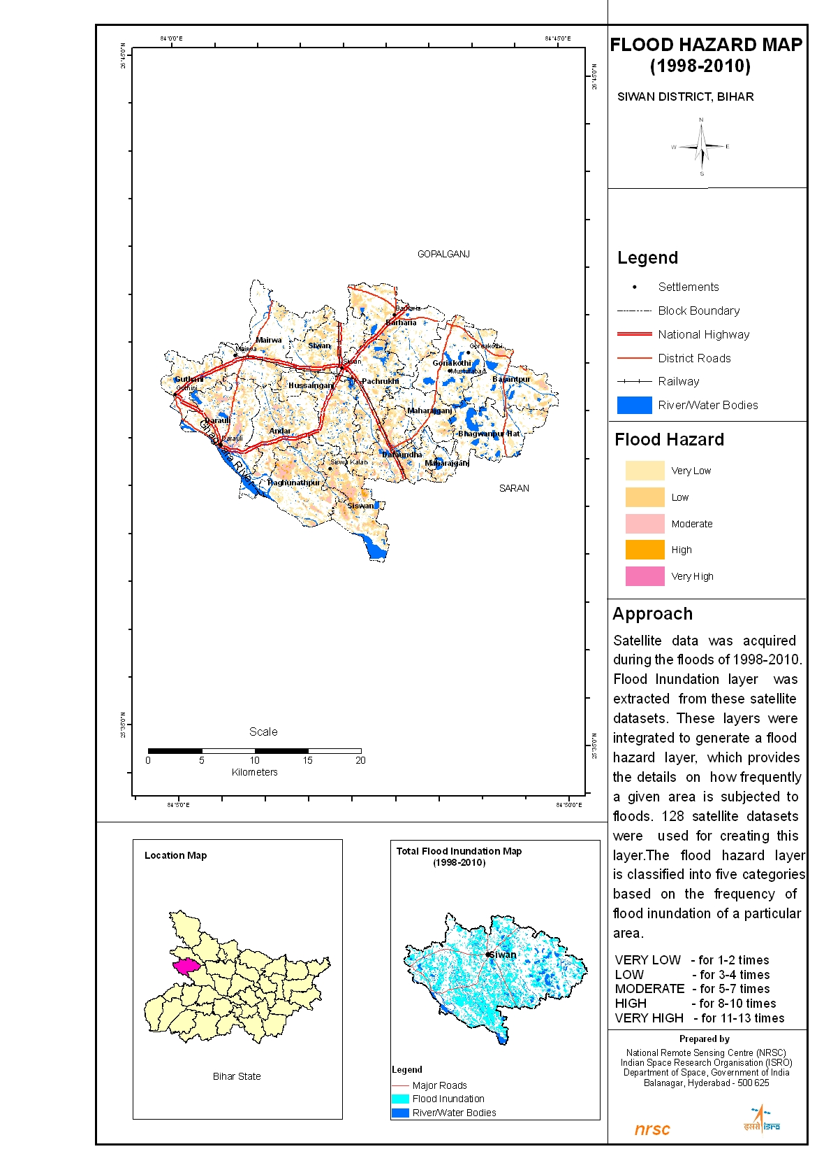
Flood hazard Maps

Action Oriented Plan
Preparation of plans: All districts will have DDMPs and all constituents (administration, CBOs, CSOs and PRIs) are aware of such plans and their roles and responsibilities.
Dynamic plans: Districts will have improved formats for DDMP to capture hazard and risk assessment risk analysis and reduction plan (development and contingency plan) and monitoring of the plan.
Convergence and correlation: All line departments prepare their own sectoral plan and contribute to the DDMP and DDMP will be part of CDP.
HVCA: District prepares DDMP having Hazard, Vulnerability and Capacity Assessments (HVCA) which lead to comprehensive contingency and risk reduction plan.
Sustainability: Commitment from state and district authorities to adopt the process and methodologies for DDMPs.

Scope of the Project

Approach for Comprehensive Plan
The approach towards the entire exercise would include secondary data collection, stakeholder mapping, survey tool development including development of questionnaire, checklist and draft template, training of local survey teams, primary data collection and use of GIS for hazard mapping, resource mapping and vulnerability mapping.
District level consultation will be organised in each proposed project district during the project to revise the outline to make the DDMP Inclusive. This will be mainly with District, Disaster Management Authority (DDMA) and other line departments, PRIs, municipalities/ municipal corporations, grassroots organisations/CBOs and communities. This will be facilitated by Caritas India along with DDMA of the respective districts.
The outputs will be the district level Advisory Committee of each district and detail timeline from district authorities to adopt the process and methodologies of Multi hazard DDMP.

Consideration for lower administrative units below district – Block & Panchayat level interventions
Each Panchayat and Block will be involved in the DDMP planning process. There will be a consultation at district level for all these lower administrative units below districts. In these consultation the participants will be provided with a simple data collection formats for collecting data in terms of Hazard Vulnerability and Capacity of their respective Panchayats. They will be trained in collecting data in a participatory way involving their local community.

Mainstreaming DRR & CCA to be taken into consideration
The mainstreaming of DRR and CCA will be done with the help of local community. The DRR basically will be reflected in preparedness plan of the districts. For e.g. the annual plan updating is one of the best example of the DRR. This will be a big achievement that the entire district level stakeholders at their own level seriously review their plan and make necessary preparedness before the any disaster occurs. So during the planning exercise each line department will participate in the consultation and share how and what DRR measures their respective department will adopt so that the loss in case of any disaster is reduced.
In the similar line the Climate Change adaptation will also be introduced in the DDMP. The community and the respective departments will be oriented on the CCA details and how they can make use of it in there planning exercise.

Value addition by agencies
Caritas India will introduce the innovations in each of the DDMP based on the local context. We have a first-hand experience of making of DDMP in Madhubani, so we will avoid all the shortcomings happened in Madhubani in our 4 districts. Caritas India is also State Training agency under Gov. of Bihar under NRHM program, so we will highlight the health issues in the DDMP and address the health issues during disasters. Caritas India in Bihar is working with most marginalized musahar communities. We shall try to bring their voice and address their issues during disaster through this inclusive DDMP. Caritas India has a long working experience in Bihar and at present working with 10 NGO partners in Bihar, their grass root level expertise will be used in this DDMP making process.

Districts’ Profile

Multi-hazard focus - including vulnerabilities in terms of socio-economic details and also the capacities existing in the districts
Siwan, situated in the western part of the State, was originally a sub-division of Saran District, which in ancient days formed a part of Kosala Kingdom. The present district limits came into existence only in 1972, which is geographically situated at 25º35 North and 84º1 to 84º47 east. The total area of the Siwan district is about 2219.00 Sq. Km. with a population of 21,56,428 as per the 1991 census. The district is bounded on the east by the Saran district, on the north by Gopalganj district and on the west and south by two districts of U.P. viz. Deoria and Balia respectively. Siwan derived its name from "Shiva Man", a Bandh Raja whose heirs ruled this area till Babar’s arrival. Maharajganj, which is another subdivision of Siwan district, may have found its name from the seat of the Maharaja there. A recently excavated marvelous statue of Lord Vishnu at Village Bherbania from underneath a tree indicates that there were large numbers of followers of Lord Vishnu in the area. As the legend goes, Dronacharya of Mahabharat belonged to village ‘DON’ in Darauli Block. Some believe Siwan to be the place where Lord Buddha died. Siwan is also known as AliganjSawan after the name of Ali Bux, one of the ancestors of the feudal lords of the area. Siwan was a part of Banaras Kingdom during 8th century. Muslims came here in the 13th century. Sikandar Lodi brought this area in his kingdom in 15th century. Babar crossed Ghaghrariver near Siswan in his return journey. In the end of the 17th century, the Dutch came first followed by the English. After the battle of Buxar in 1765 it became a part of Bengal. Siwan played an important role in 1857 independence movement. It is famous for the stalwart and sturdy ‘Bhoj-puries’, who have always been noted for their martial spirit and physical endurance and from whom the army and police personnel were largely drawn. A good number of them rebelled and rendered their services to BabuKunwar Singh. The anti pardah movement in Bihar was started by Sri Braj Kishore Prasad who also belonged to Siwan in response to the Non Co-Operative movement in 1920. A big meeting was organised at Darauli in Siwan District on the eve of the KartikPurnimaMela under the leadership of Dr.Rajendra Prasad who had thrown away his lucrative practice as an advocate in the Patna High Court at the call of Gandhiji. In the wake of this movement MaulanaMazharulHaque, who came to stay with his maternal uncle Dr.SaiyyadMahmood in Siwan, had constructed an ashram on the Patna-Danapur road which subsequently became Sadaquat Ashram The next phase of the Non co-operation movement known as the Civil Disobedience movement of 1930, was fully implemented in Siwan. In connection with the Satyagrah Movement Pt. Jawaharlal Nehru made a whirlwind tour of the different parts of Bihar. One of the famous meetings he addressed was at Maharajganj. A few persons of present Siwan District who played an important role in the attainment of independence were Dr.Rajendra Prasad, MaulanaMazharulHaque, Shri Mahendra Prasad the elder brother of Dr.Rajendra Prasad, Dr.Sayyad Mohammad, Shri Braj Kishore Prasad and Shri Phulena Prasad. Uma Kant Singh (Raman jee) of Narendrapur achieved martyrdom during the Quit India Movement. Jwala Prasad and Narmedshwar Prasad of Siwan helped Jai Prakash Narayan after his escape from Hazaribagh Central Jail. One of the most renowedliteraturer of this country Pandit Rahul Sankritayayana started peasant Movement here between 1937 to 1938. During his visit to Champaran Mahatma Gandhi and Madan Mohan Malviya visited Siwan and Gandhiji even spent a night at Zeradei in the house of Dr.Rajendra Prasad. The chowki on which he slept then is still kept intact there.

DisasterRisk and Vulnerability Profile
The District Siwan is spanned over the western part of North Bihar alluvial plain's segment of broader IndoGangetic Plain. The geographical location of the district is confined between 250 53' to 260 23' North latitudes and 840 1' to 840 47' East longitude. The Deoria district (U.P.) bound it from west, the Gopalganj district from north, the Saran district from east and by the river Ghaghara (Gogra or Sarayu) from south, beyond which lies the district of Ballia (U.P.). The district is constituted of 15 (1991) Anchals (blocks) covering an area of 2219 sq. km. (856 miles) with a population of 2170971 according to 1991 census. This administrative unit embraces only 1.27 percent of area and 2.54 percent of total population of Bihar. It comprises of 1437 inhabited and 101 uninhabited villages. As regards the sex ratio in the district, 1069 female population comes to per 1000 male population. Structurally the district forms a part of the alluvium of the broader Indo-Gangetic Plain. The geological formation of the tract is of recent (Holocene) period. The contribution of the Himalayan Rivers to the formation of the tract is significant. It is estimated that the district covers the deposits of alluvium more than 5000 feet depth. geomorphologically it forms the part of the Gandak cone which is the outcome of the discharge and silt-charge of the Himalayan rivers to the plain during the phase of deposition. The whole district bears a featureless terrain having 13 general slope from northwest to southeast. The slope is almost imperceptible averaging only 8 inches a mile. The datum line of Siwan, the district headquarters, is 64 metres (210 feet) from the sea level. The district is drained by few small rivers like Jharahi, Daha, Gandaki, Dhamati (Dhamahi), Siahi, Nikari and Sona. The southern boundary of the district is formed by river Ghaghara, the main stream of the area. Among these, Ghaghara is the only perennial river because of its Himalayan source and rest rivers bear different origins. The rivers of the district get inundated almost every year. The area is characterised by certain typical features like 'Chaurs', some of which give birth to short length streams locally known as 'Nadi' or 'Sota'. The rivers Jharahi and Daha are the tributaries of river Ghaghara, while Gandak and Dhamati are of river Gandak. The Siahi and Nikari streams drain to Jharahi, While Sona drains to river Daha. These streams play important role in carrying out excess water during rainy season. Siwan, the district headquarters, is located on the eastern bank of river Daha. The southern part of the district along river Ghaghara is marked by ‘Draras’, which are typical formation of the sand heaping with thin layer of clay and silt over them. Alluvium and dilution Rae the important works of river Ghaghara in this part, where by boundary problems are created leading to transfer of land to and from the district. The district of Siwan falls in the area, which occupies an intermediary position between the Bhanger plain of Uttar Pradesh and Khader plain of West Bengal. ‘Bhanger’ ( or Banger ) is the older alluvium containing heavier soil with greater clay proportion, while Khader is the newer alluvial deposit by rier floods, Both types of soils are found in the district, but Khader is limited to the vicinity of the rivers where it is periodically renewed by fresh deposits, especially in “DIARA” areas. Khader is locally termed as 'Domat' and ‘Bhanger’ as 'Balsundari'. The Bhanger contains nodular segregations of carbonate of lime known as 'Kankar'. The soil is in many places sulfurous and extraction of saltpeter has long been an important industry. The saltpeter industry has disappeared with the march of time and changing phase of development. The district gets its place in the transitional zone of drier climatic condition of Uttar Pradesh and moist climatic condition of West Bengal, but nearness to U.P. gives way to experience comparatively drier climatic condition. The area observes hot westerly winds which start in March and last till May, but in April and May light, damp easterly winds blow intermittently and afternoon storms accompanied with rain take the place of the rainless dust storms of U.P. The summer season experiences 'Loo' during May and June having temperature above 1000 F (380C), Since the district is in transitional zone the Monsoon rain starts late here, but earlier than U.P., and persists till September. This period provides maximum rain to the area. July and August are the oppressive months due to heat intermixed with high humidity. The winter season is normally pleasant with low temperature. During this period western depressions sometimes give small quantity of rain, which intensifies the existing coldness into chill. The average annual rainfall for 51 years at Siwan is 120 centimeters( 47 inches).

Approach, Methodology and Activities

Data Sources – Primary & Secondary (including relevant maps)
- Meeting with District Magistrate, Line Department officials, Bihar Inter Agency Group to know their perspective on DDMPs. The existing data in the district will will be collected from the different line department of the respective districts. The NIC of the respective districts will be involved in the data compilation.
- Meetings with PRI members and local NGOs to know the local issues and risks which is occurring in the districts. The Participatory risk assessment exercise in details will be planned with the help of local Panchayats.
- Secondary data from various sources for Hazard, Vulnerability and Capacity Analysis. The data will be collected from all the source available in the districts such as line department, university and also from different NGOs.
- Once we complete the data collection and compilation, a team will do the data analysis. On the basis of this data analysis a detail HVCA report will be prepared which will be shared with different stakeholders. A series of consultations with line departments, PRIs and Communities and Local NGOs done in order to review a draft HVCA report of the district
- Sample Data from Gram Panchayat to be collected by the personnel. By involving the volunteers available in the district like Nehru Yuva Kendra, NGO Volunteers etc. sample data collection at Panchayat level will be done. The prime objective of this data collection will be to bring the people’s voice in the DDMP and which will make it more inclusive.
- 2 % of total Gram Panchayat to be checked and verified

Stakeholders’ involvement (including IDRN)
Sr. No. | Name of Partner Agency | Role
1 | Caritas India | Facilitating Agency (Lead Agency)  - Coordinate the entire initiative  - Engaging with BSDMA and DDMA  - Coordinate with all the partners of BSDMA  - Coordinate with state and district governments  - Jointly organise district level consultation with respect DDMA and state authority in each district  - Prepare training module  - Conduct ToTs
4 | SDMAs | - State Level Guidance and Approvals  - Facilitate district authorities  - Presence and guidance during state consultation
5 | DDMAs | - District Level Guidance and Approvals  - Line department coordination  - Communication  - Logistic arrangement  - Coordination with panchayats  - Support and linkage to Flagship schemes  - Commitment to link DRR with Panchayat plans
6 | PRIs and municipalities/ municipal corporation and Grassroot Organisations | - Grass root level support and guidance to design outline of DDMP  - Commitment to capture voices of vulnerable groups in DDMP  - Coordinate with government agencies and get the plans of district consultations implemented
7 | Bihar Inter Agency Group (BIAG) | - Coordinate with BSDMA and Department of Disaster Management;  - Coordinate with other agencies doing DDMP in other districts of Bihar;  - Guidance to organise consultations on HVCA and DDMP Framework

DDMP Preparation Planning & and Reporting Mechanism

Ensuring involvement and ownership of DDMAs
District level consultation will be organised in each proposed project district during the second month of the project to revise the outline to make the DDMP Inclusive. This will be mainly with District, Disaster Management Authority and other line departments, PRIs, municipalities/ municipal corporations, grassroots organisations/CBOs and communities. This will be facilitated by Caritas India and other respective local NGOs of the local area. The outputs will be the district level Advisory Committee of each district and commitment from district authorities to adopt the process and methodologies of DDMP. In each and every steps the DDMA will be involved so that they are aware about the entire process. The agency will also orient the entire district team so that the DDMA take lead from following year to update the DDMP if required.

Timeline and Delivery Schedule (Table)
 | Activity | Activity Description | Output | Timeline
1. | Meeting with Different stake holders | Meeting with District Magistrate, Line Department officials, Bihar Inter Agency Group to know their perspective on DDMPs | Stakeholders would know the process and agreed to do work together | 1st Month
2. | Meeting with PRIs and other NGOs | Meetings with PRI members and local NGOs to know the local issues and risks which is occurring in the districts | PRIs and other NGOs have their common understanding and extend their arm for DDMPs | 1st Month
3. | Collection of secondary data for Hazard, Vulnerability, Capacity Analysis | Secondary data from various sources for Hazard, Vulnerability and Capacity Analysis | Mapping the different kind of disaster occurred in areas. | 2nd Month
4. | Consultation for HVCA report | A series of consultations with line departments, PRIs and Communities and Local NGOs done in order to review a draft HVCA report of the district | To know how disaster which was happen and do all the vulnerability is mapped correctly | 2nd Month
5. | Sample Data Collection | Sample Data from Gram Panchayat to be collected by the personnel | To have firsthand data for making the plan | 3rd Month
6. | Verification of data | 2 % of total Gram Panchayat to be checked and verified | Data checked and verified | 3rd Month
7. | Consolidation of Data | The data coming from villages will be punched in excel | Digitalization of all data into soft. | 4th Month
8. | Analysis of Data | The consolidated data will be analyzed. | Draft report of DDMP will be prepared | 4th Month
9. | Draft report presentation | The draft report will be developed and it will be presented in fronts of district officials and Line departments | Feedback on the draft report will be taken and suggestion will be incorporated. | 5th Month
10. | Draft report to be send to BSDMA | The draft report after taking feedback from district official with correction it will send to BSDMA for approval | Finalization of DDMP | 5th Month
11. | Finalization of DDMP | Finalization of DDMP plan after getting some of feedback from BSDMA | DDMP got approval from concerned District | 6th Month
12. | Submission of Final Plan | Final Plan will be submitted to District and as well as BSDMA for approval. | DDMP plan finalized and submitted to concerned Authority | 6th Month
Threat : Assembly Election may hinder to collect data and organize workshop, interview with Government officials

Monitoring and Evaluation System
The project team involved in the making of DDMP in all respective districts are DRR expertise. We will engaged external consultants for the periodic monitoring of the DDMP making process. The District Administration (DDMA) is the prime responsible for the making of DDMP. We shall coordinate with the respective districts point person nominated by DDMA and SDMA to move the work forward.
- Line of internal accountability/reporting: District Coordinators will be reporting to the DDMA and Caritas India Team Leader each week and the Team leader will report to the BSDMA and Caritas India Director about progress and future action plan.
- Data collection, compilation and analysis and decision making processes and tools: Caritas India Team Leader along with DDMA will develop tools for data collection and analysis with the support from BSDMA Resource Person.
- Frequency of reviews/decision making meetings: For project monitoring and reporting a monthly meeting of all team members is decided at organization headquarter or sometimes in the districts. The BSDMA resource person will also be participating in the monthly review meeting.
- Reporting to internal stakeholders and to BSDMA: Monthly progress report will be sent to BSDMA along with action plan of next month.
- Feedback: The District Coordinator will take regular feedback from DDMA and will share the same with the team leader. Also feedback will be taken from resource persons BSDMA and other visitors to the project area.
- Documentation: The reports from the field will be documented by the district Coordinators. The team Leader will be responsible for the consolidation of report and sharing it with BSDMA.

Project Team

Team Leaders and other Team Members – CV (Qualifications and Experience), Roles and Responsibilities etc.
S.No. | Name of Personnel | Area of expertise | Designation & Organization | Year of Experience
1. | Girish Peter | Community Mobilization, Disaster Management, Human Rights | Team Leader | 12
2. | Chandan | Livelihood and participatory planning | District Coordinator (Buxar) | 5
3. | Abhishek Kumar | Community mobilization and Liasoning with Government | District Coordinator (Siwan) | 7
4. | PoojaRana | Community mobilization and Disaster Management | District Coordinator (Saran) | 4
5. | Saurabh Kumar | Community mobilization and Disaster Management | District Coordinator (Gopalganj) | 3
6. | Anjan Bag | DRR planning and Risk Mitigation | Technical Support | 15
7. | Munish Kaushik | Project Management, DRR and Advocacy | Technical Support | 14
8. | Babita Alick | Mass Communication, Disaster Management | Technical Support | 16

